**CASE STUDY**

1. Test plan created. Added HTTP cookie manager, HTTP cache manager, HTTP request defaults, Thread group ,Prometheus Listner .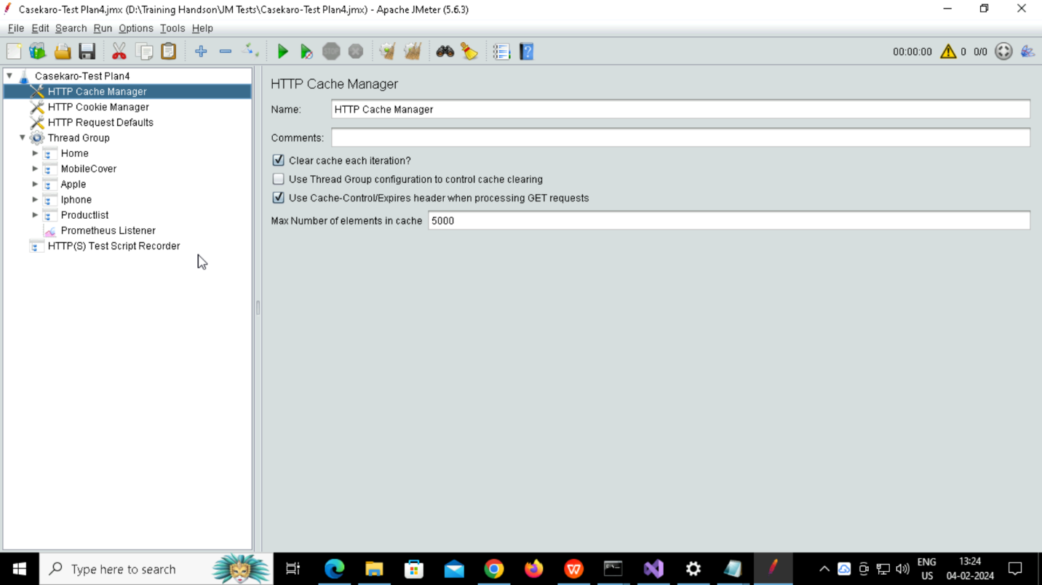
2. Added HTTP(s) TestScript Recorder

3.Added Rules.yml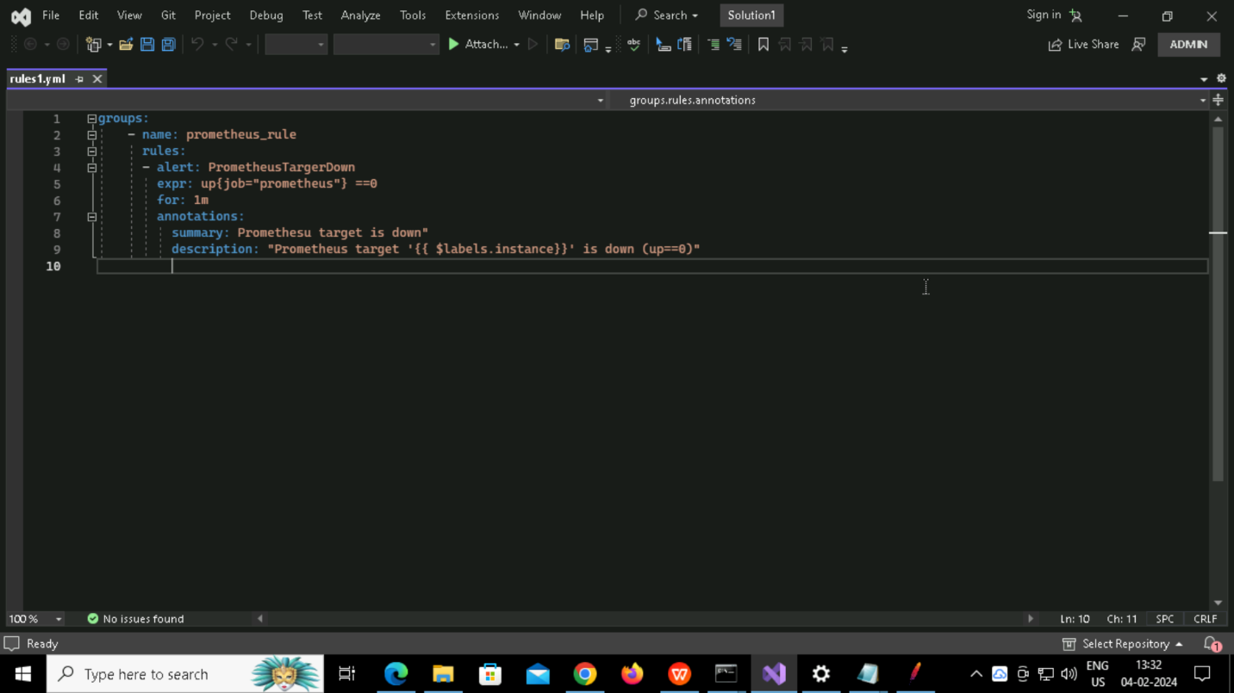

6. All fired in prometheus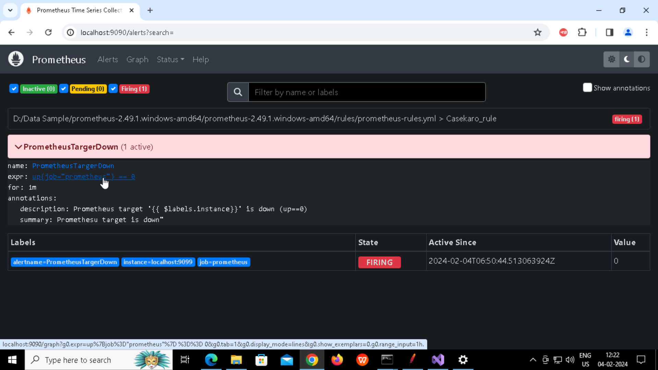

8.Ran jmeter in non GUI mode , created logfile and report.

